FOR IMMEDIATE RELEASE  14 June 2024  Lynne Clay| Marketing | Media | Communications  Tenpin Bowling Association of Queensland Inc.  Sports House | 150 Caxton Street l Milton QLD 4064  e: lynne.clay@outlook.com | www.tbaq.org.au  t: 02 9999 2210 m: 0419 444 280 |   TBAQ proudly supported by Queensland  State Government
TENPIN BOWLING – A SPORT FOR ALL!
Logan City Tournament Attracts Competitors from Far and Wide

Tenpin bowling is fun to play with family and friends and even more fun – and challenging - as a highly competitive sport.
Hugely popular with teenagers and younger players, the sport will showcase some of Australia’s top talent at Logan City Tenpin Bowling Centre for three action-packed days between 29th June and 1st July.
Only a limited number of entries are now available for the 2024 Queensland Junior Cup and Queensland Youth Cup with close to 100 bowlers from across the country expected to compete. A total prize pool worth more than $12,000 including cash, trophies and an array of prizes is on offer.
“We already have 5 out of 8 squads completely filled,” said TBAQ Junior Committee Chair Jodi Bishop today. “We are one of very few ranked events that have equal prize money for both male and female bowlers across all divisions and we’re very proud of this.”
“The tournament has attracted participants from far and wide - Queensland, New South Wales, Victoria, South Australia, Tasmania and New Zealand – and we’ve also had a tremendous response from the local region,” she pointed out.
At last year’s Queensland Junior Cup, the youngest competitor was 8 year-old Harper Mundraby from Logan. Harper is one of many local bowlers eager to return for this year’s event while an even younger Ipswich youngster, 6 year-old Charlotte Brearley, is the youngest player registered to compete this year.
“Charlotte began bowling at just 18 months of age with the assistance of a guide ramp, and once she was able to throw a ball independently she adopted the two-handed delivery technique of her hero, world #1 professional bowler Jason Belmonte,” Jodi explained.
“At the age of four, Charlotte was enrolled in the sport’s junior training program ‘Bowl Patrol’ and progressed from bowling with lane bumpers 12 months ago to an accomplished and very keen right-handed bowler. “She loves to bowl, and given the chance would be on the lanes every day! With such enthusiasm and a PB of 160 at the age of just 6 Charlotte is an emerging star to watch,” Jodi added with a smile.

The contingent of players entering this year’s tournament is boosted by several family groups: three sisters (Chloe, Kayla and Talia Piffero); three pairs of brothers - Noah and Nicholas Rajkovic, Oliver and William Zaccaria and Justin and Julian Dinham; two sets of cousins - Brooke and Deakin Buckingham and Brianna and Bronx Walsh; and brother/sister duos Harlem and Tayreese Morris, Alex and Charlotte Mahoney and Beau and Lexi Colgan.
Currently studying in the United States at the Savannah College of Art & Design in Georgia, 20 year-old Connor Bishop is flying back to his home base in Logan this week for the tournament and to spend time with his family too, including cousins, the Piffero trio. In addition to the Queensland Youth Cup, Connor plans to compete in several tournaments on the sport’s busy calendar while he’s here during the American university’s summer break.
Also flying in from overseas will be 15 year-old Cooper Mollet from New Zealand. Cooper started competing in 2020 after watching his father bowl for many years and now lives and breathes bowling. With a personal best near-perfect score of 299, and impressive 3-game and 4 game series highs Cooper will add serious international pressure from across the ditch.
The countdown has now begun to 29th June and three days of pin-flying competition at Logan City Tenpin. Spectators are welcome to watch the excitement, skill and challenge of competitive tenpin bowling – admission for spectators is free.
For further details please contact organising committee Chair Jodi Bishop via email sqjuniors@tbaq.org.au or phone 0415 869 938.

Tags: #qjc@logan #bestrankedeventinaus #equalprizemoney #QJC2024

ends

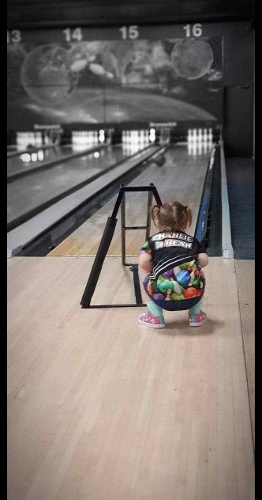 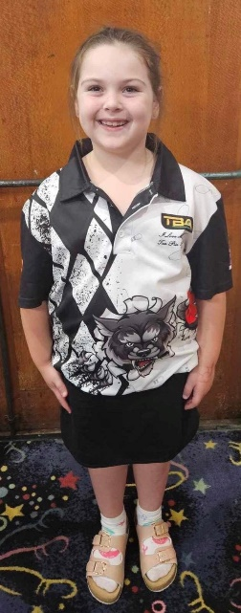 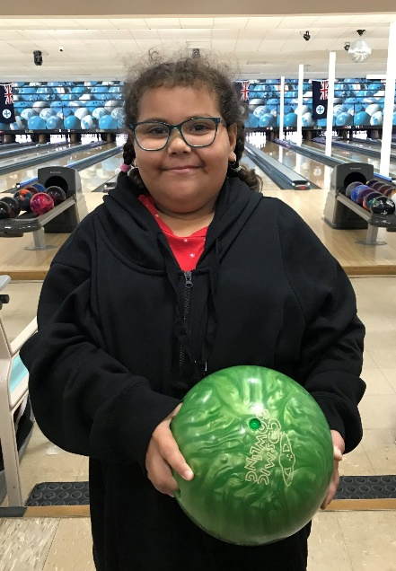
6 yo Charlotte Brearley has progressed from Another keen local competitor,
ramp to future champ 8 yo Harper Mundraby

MEDIA ENQUIRIES AND FURTHER IMAGES, PLEASE CONTACT LYNNE CLAY – 0419 444 280



